**Homework**

**201133216**

**정유석**

**Screen Shot**

* **Screen shot 2-A**

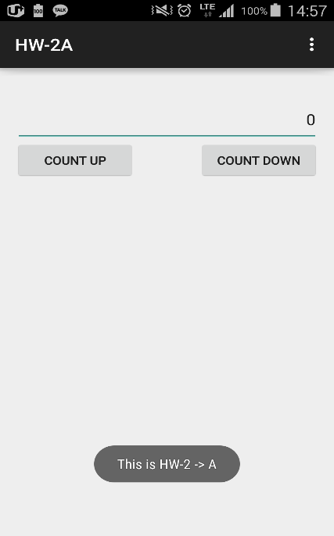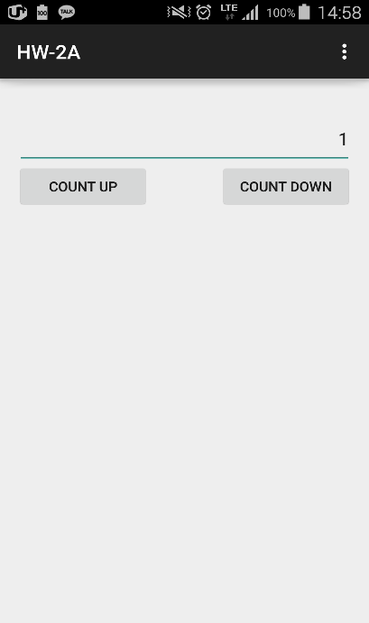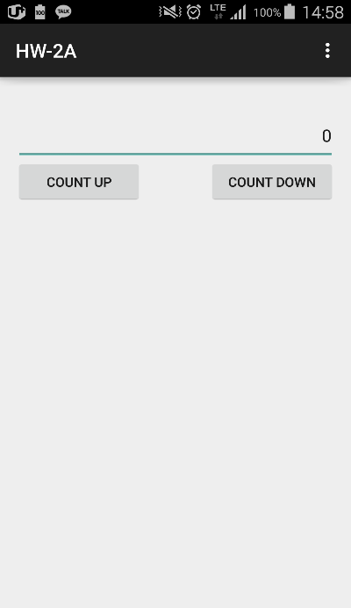

**<First> < Click the count up> <Clcik the count down>**

* **Screen shot 2-B**

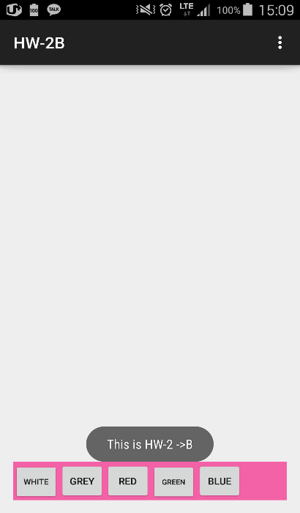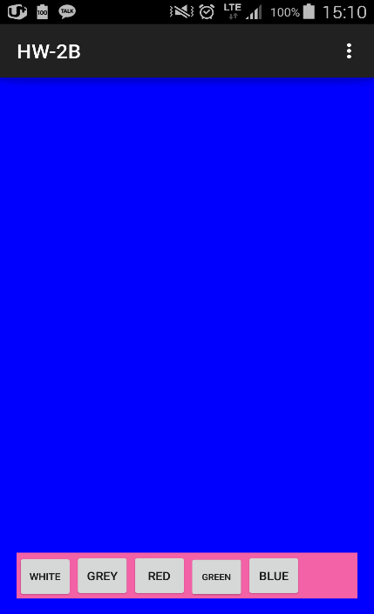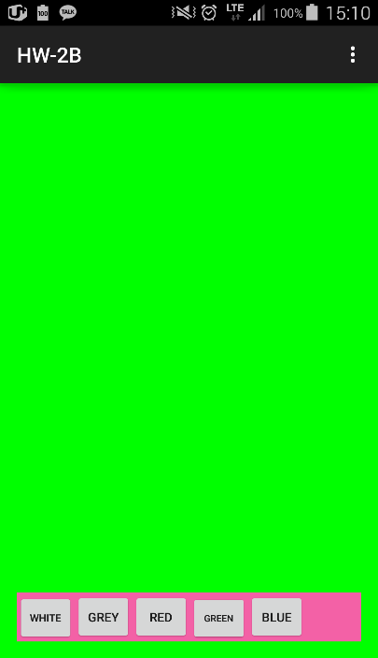

**<First> <Blue button> <green Button>**

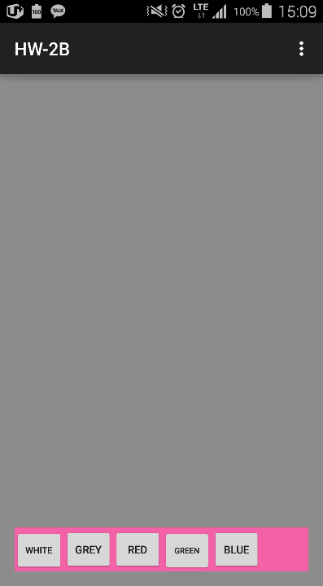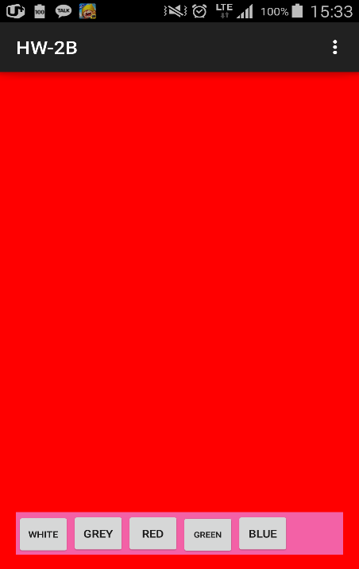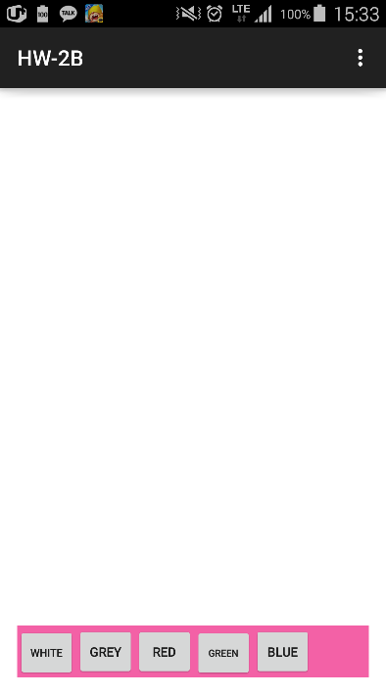

**<Grey button> <Red button> <White button>**

* **Screen shot 2-C**

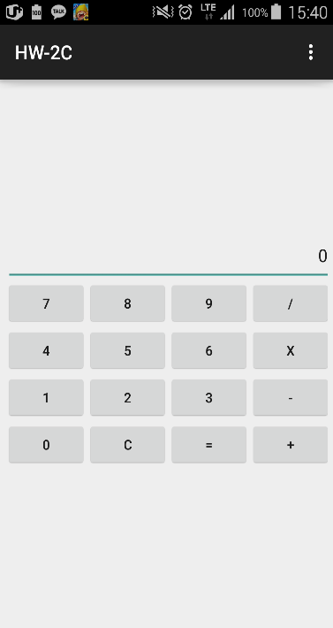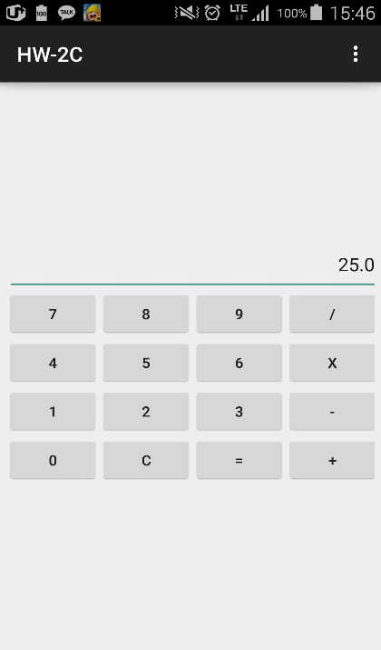

**<First> <25> <X(mutiply)>**

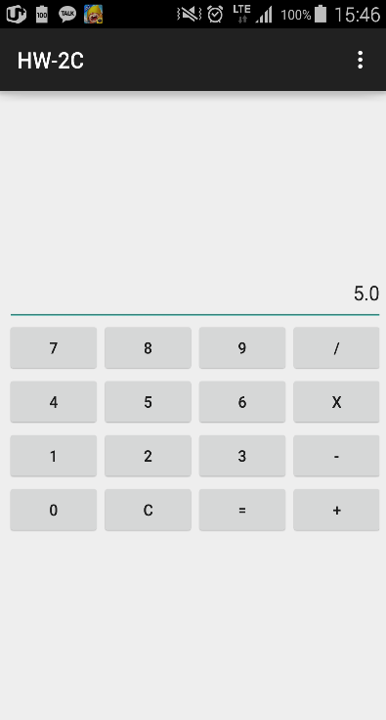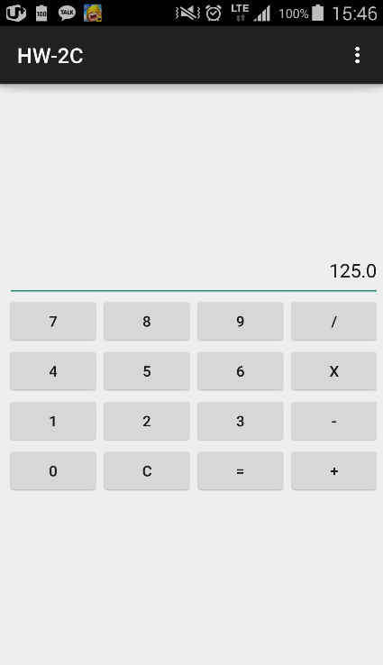

**<5> < = > < / >**

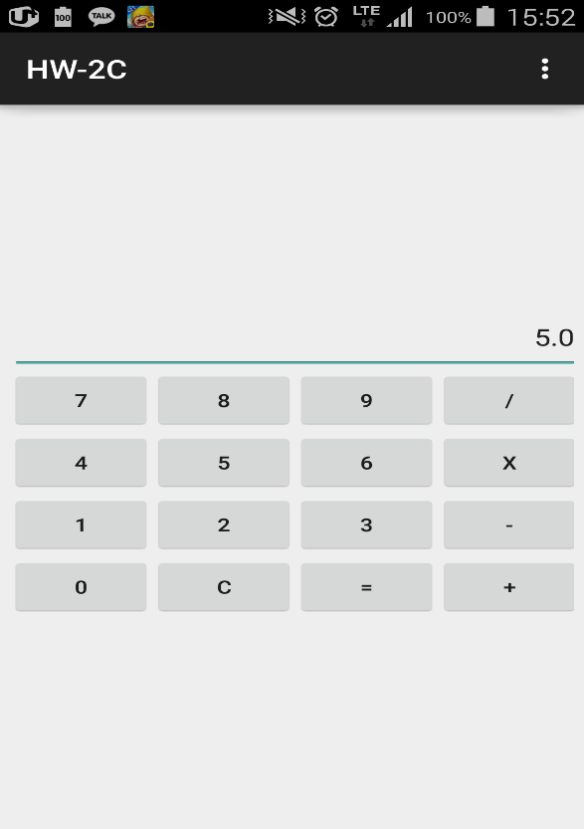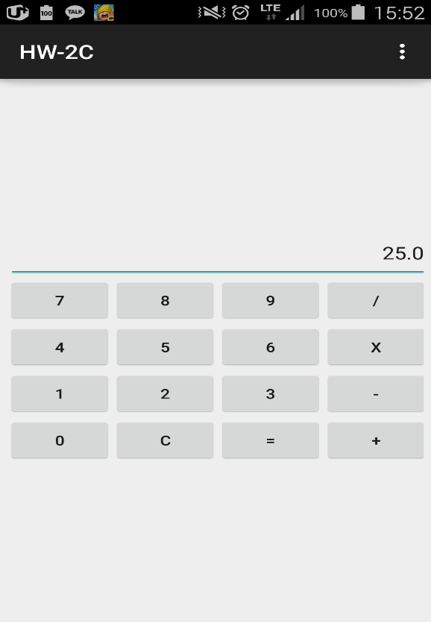

**< 5 > < = >**

**CODE**

**Homework 2 – B**

* **MainACtivity**

package com.example.hw_2a;

import android.support.v7.app.ActionBarActivity;

import android.os.Bundle;

import android.view.Menu;

import android.view.MenuItem;

import android.view.View;

import android.view.View.OnClickListener;

import android.widget.Button;

import android.widget.EditText;

import android.widget.Toast;

public class MainActivity extends ActionBarActivity implements OnClickListener {

Button button_UP,button_Down; //They are used to connect activity

EditText text; //It is used to connect activity

@Override

protected void onStart(){ //It represents homework number using toast

super.onStart();

Toast.makeText(this, "This is HW-2 -> A", Toast.LENGTH_SHORT).show(); //Make toast

}

@Override

protected void onCreate(Bundle savedInstanceState) {

super.onCreate(savedInstanceState);

setContentView(R.layout.activity_main);

text = (EditText)findViewById(R.id.textView1); //Connect to activity using R class

button_UP = (Button)findViewById(R.id.B_UP); //Connect to activity using R class

button_Down = (Button)findViewById(R.id.B_DOWN); //Connect to activity using R class

button_UP.setOnClickListener(this); //Make event listener

button_Down.setOnClickListener(this);

}

@Override

public void onClick(View v) {

//Count up button

if(v.getId() ==button_UP.getId()){

String temp = text.getText().toString(); //Receive the text string

int tmp = Integer.parseInt(temp); //Convert to integer

tmp++; //Count up

text.setText(Integer.toString(tmp)); //Set count to text

}

//Count down button

if(v.getId() ==button_Down.getId()){

String temp = text.getText().toString(); //Receive the text string

int tmp = Integer.parseInt(temp); //Convert to integer

tmp--; //Count down

text.setText(Integer.toString(tmp)); //Set count to text

}

}

@Override

public boolean onCreateOptionsMenu(Menu menu) {

// Inflate the menu; this adds items to the action bar if it is present.

getMenuInflater().inflate(R.menu.main, menu);

return true;

}

@Override

public boolean onOptionsItemSelected(MenuItem item) {

// Handle action bar item clicks here. The action bar will

// automatically handle clicks on the Home/Up button, so long

// as you specify a parent activity in AndroidManifest.xml.

int id = item.getItemId();

if (id == R.id.action_settings) {

return true;

}

return super.onOptionsItemSelected(item);

}

}

* **Activity_main**
* <RelativeLayout xmlns:android=*"http://schemas.android.com/apk/res/android"*
* xmlns:tools=*"http://schemas.android.com/tools"*
* android:layout_width=*"match_parent"*
* android:layout_height=*"match_parent"*
* android:paddingBottom=*"@dimen/activity_vertical_margin"*
* android:paddingLeft=*"@dimen/activity_horizontal_margin"*
* android:paddingRight=*"@dimen/activity_horizontal_margin"*
* android:paddingTop=*"@dimen/activity_vertical_margin"*
* tools:context=*"com.example.hw_2a.MainActivity"* >
* <!-- Make views -->
* <!-- width = match_parent , height = wrap_content,
* gravity = Set text location to right
* cursorVisible = "false" means user doesn't touch text
* -->
* <EditText
* android:id=*"@+id/textView1"*
* android:layout_width=*"match_parent"*
* android:layout_height=*"wrap_content"*
* android:layout_alignParentLeft=*"true"*
* android:layout_alignParentRight=*"true"*
* android:layout_alignParentTop=*"true"*
* android:layout_marginTop=*"29dp"*
* android:gravity=*"right"*
* android:ems=*"10"*
* android:text=*"0"*
* android:cursorVisible=*"false"*
* >
* <requestFocus />
* </EditText>
* <!-- weight = same size with button of count down
* alignLeft, below mean it location is edit text down and left
* -->
* <Button
* android:id=*"@+id/B_UP"*
* android:layout_width=*"130dp"*
* android:layout_height=*"wrap_content"*
* android:layout_alignLeft=*"@+id/textView1"*
* android:layout_below=*"@+id/textView1"*
* android:layout_weight=*"2"*
* android:text=*"Count Up"* />
* <Button
* android:id=*"@+id/B_DOWN"*
* android:layout_width=*"130dp"*
* android:layout_height=*"wrap_content"*
* android:layout_alignBaseline=*"@+id/B_UP"*
* android:layout_alignBottom=*"@+id/B_UP"*
* android:layout_alignRight=*"@+id/textView1"*
* android:layout_weight=*"2"*
* android:text=*"Count Down"* />
* </RelativeLayout>

**Homework 2 – B**

* **MainActivity**

package com.example.hw_2b;

import android.support.v7.app.ActionBarActivity;

import android.graphics.Color;

import android.os.Bundle;

import android.view.Menu;

import android.view.MenuItem;

import android.view.View;

import android.view.View.OnClickListener;

import android.widget.Button;

import android.widget.RelativeLayout;

import android.widget.Toast;

public class MainActivity extends ActionBarActivity implements OnClickListener {

Button B1,B2,B3,B4,B5; //Make buttons (Using connect to activity)

RelativeLayout RL; //Make Layout (Using connect to activity)

@Override

protected void onStart(){ //It represents homework number

super.onStart(); //Make toast

Toast.makeText(this, "This is HW-2 ->B", Toast.LENGTH_SHORT).show();

}

@Override

protected void onCreate(Bundle savedInstanceState) {

super.onCreate(savedInstanceState);

setContentView(R.layout.activity_main);

//Connect to activity using R class

RL = (RelativeLayout)findViewById(R.id.RTL);

B1 = (Button)findViewById(R.id.White);

B2 = (Button)findViewById(R.id.Grey);

B3 = (Button)findViewById(R.id.Red);

B4 = (Button)findViewById(R.id.Green);

B5 = (Button)findViewById(R.id.Blue);

//Make event listener

B1.setOnClickListener(this);

B2.setOnClickListener(this);

B3.setOnClickListener(this);

B4.setOnClickListener(this);

B5.setOnClickListener(this);

}

@Override

public void onClick(View v){

//Click the white button, change the layout background to white

if(v.getId() == B1.getId())

RL.setBackgroundColor(Color.rgb(255, 255, 255));;

//Click the grey button, change the layout background to grey

if(v.getId() == B2.getId())

RL.setBackgroundColor(Color.rgb(140, 140, 140));;

//Click the red button, change the layout background to red

if(v.getId() == B3.getId())

RL.setBackgroundColor(Color.rgb(255, 0, 0));;

//Click the green button, change the layout background to green

if(v.getId() == B4.getId())

RL.setBackgroundColor(Color.rgb(0, 255, 0));;

//Click the blue button, change the layout background to blue

if(v.getId() == B5.getId())

RL.setBackgroundColor(Color.rgb(0, 0, 255));;

}

@Override

public boolean onCreateOptionsMenu(Menu menu) {

// Inflate the menu; this adds items to the action bar if it is present.

getMenuInflater().inflate(R.menu.main, menu);

return true;

}

@Override

public boolean onOptionsItemSelected(MenuItem item) {

// Handle action bar item clicks here. The action bar will

// automatically handle clicks on the Home/Up button, so long

// as you specify a parent activity in AndroidManifest.xml.

int id = item.getItemId();

if (id == R.id.action_settings) {

return true;

}

return super.onOptionsItemSelected(item);

}

}

* **Activity_main**
* <RelativeLayout xmlns:android=*"http://schemas.android.com/apk/res/android"*
* android:id=*"@+id/RTL"*
* xmlns:tools=*"http://schemas.android.com/tools"*
* android:layout_width=*"match_parent"*
* android:layout_height=*"match_parent"*
* android:paddingBottom=*"@dimen/activity_vertical_margin"*
* android:paddingLeft=*"@dimen/activity_horizontal_margin"*
* android:paddingRight=*"@dimen/activity_horizontal_margin"*
* android:paddingTop=*"@dimen/activity_vertical_margin"*
* tools:context=*"com.example.hw_2b.MainActivity"* >
* <!-- Using LinearLayout
* orientation = horizontal means it makes all views set horizontal -->
* <LinearLayout
* android:id=*"@+id/LL1"*
* android:layout_width=*"wrap_content"*
* android:layout_height=*"wrap_content"*
* android:layout_alignParentBottom=*"true"*
* android:layout_alignParentLeft=*"true"*
* android:layout_alignParentRight=*"true"*
* android:orientation=*"horizontal"*
* android:background=*"#F361A6"*>
* <!-- Make buttons (Same width) -->
* <Button
* android:id=*"@+id/White"*
* android:layout_width=*"55dp"*
* android:layout_height=*"wrap_content"*
* android:text=*"White"*
* android:textSize=*"10dp"* />
* <Button
* android:id=*"@+id/Grey"*
* android:layout_width=*"55dp"*
* android:layout_height=*"wrap_content"*
* android:text=*"Grey"*
* android:textSize=*"12dp"* />
* <Button
* android:id=*"@+id/Red"*
* android:layout_width=*"55dp"*
* android:layout_height=*"wrap_content"*
* android:layout_alignBottom=*"@+id/button3"*
* android:layout_alignLeft=*"@+id/linearLayout1"*
* android:text=*"Red"*
* android:textSize=*"12dp"*
* />
* <Button
* android:id=*"@+id/Green"*
* android:layout_width=*"55dp"*
* android:layout_height=*"wrap_content"*
* android:text=*"Green"*
* android:textSize=*"9dp"* />
* <Button
* android:id=*"@+id/Blue"*
* android:layout_width=*"55dp"*
* android:layout_height=*"wrap_content"*
* android:text=*"Blue"*
* android:textSize=*"12dp"* />
* </LinearLayout>
* </RelativeLayout>

**Homework 2 – B**

* **MainActivity**

package com.example.hw_2c;

import android.support.v7.app.ActionBarActivity;

import android.os.Bundle;

import android.view.Menu;

import android.view.MenuItem;

import android.view.View;

import android.view.View.OnClickListener;

import android.widget.Button;

import android.widget.EditText;

import android.widget.Toast;

public class MainActivity extends ActionBarActivity implements OnClickListener{

Button B0,B1,B2,B3,B4,B5,B6,B7,B8,B9,BM,BP,BD,BS,BC,BE; //Make buttons (Using connect to activity)

EditText Edit; //Make Edit (Using connect to activity)

float sum = 0; //It is used to summary in calculator

float temp = 0; //It is next operation ( ex) 5 % 5(this))

int code = 0; //code=1 -> + , code=2 -> - , code=3 -> / , code=4 -> X

int check = 0; //It is used to next calculation ( ex) 5 -> X -> 5 -> X (this) )

protected void onStart(){

super.onStart(); //Make Toast which it represents this project name

Toast.makeText(this, "This is HW-2 -> C", Toast.LENGTH_SHORT);

}

@Override

protected void onCreate(Bundle savedInstanceState) {

super.onCreate(savedInstanceState);

setContentView(R.layout.activity_main);

//It connect java and activity using R class

Edit = (EditText)findViewById(R.id.edit);

B0 = (Button)findViewById(R.id.Bzero);

B1 = (Button)findViewById(R.id.Bone);

B2 = (Button)findViewById(R.id.Btwo);

B3 = (Button)findViewById(R.id.Bthree);

B4 = (Button)findViewById(R.id.Bfour);

B5 = (Button)findViewById(R.id.Bfive);

B6 = (Button)findViewById(R.id.Bsix);

B7 = (Button)findViewById(R.id.Bseven);

B8 = (Button)findViewById(R.id.Beight);

B9 = (Button)findViewById(R.id.Bnine);

BD= (Button)findViewById(R.id.Bdevide);

BM = (Button)findViewById(R.id.Bmultiple);

BP = (Button)findViewById(R.id.Bplus);

BC = (Button)findViewById(R.id.BC);

BE = (Button)findViewById(R.id.Bend);

BS = (Button)findViewById(R.id.Bsubtract);

//It makes event listener

B0.setOnClickListener(this);

B1.setOnClickListener(this);

B2.setOnClickListener(this);

B3.setOnClickListener(this);

B4.setOnClickListener(this);

B5.setOnClickListener(this);

B6.setOnClickListener(this);

B7.setOnClickListener(this);

B8.setOnClickListener(this);

B9.setOnClickListener(this);

BD.setOnClickListener(this);

BM.setOnClickListener(this);

BP.setOnClickListener(this);

BC.setOnClickListener(this);

BE.setOnClickListener(this);

BS.setOnClickListener(this);

}

public void onClick(View v){

if(v.getId() == B0.getId()){

//Code = 0 means It is first calculation ( ex -- 5(this) X 5 )

if(code == 0){

if(sum == 0) //It means 0 is first number

sum = 0;

else //It means 0 is none first number

sum = sum * 10;

Edit.setText(Float.toString(sum));

}

else{ //Code != 0 means It is next calculation ( ex -- 5 X 5(this) )

if(temp == 0) //It means 0 is first temp number

temp = 0;

else //It means 0 is none first temp number

temp = temp * 10;

Edit.setText(Float.toString(temp));

}

}

//It is same above B0 sentence

if(v.getId() == B1.getId()){

if(code == 0){

if(sum == 0)

sum = 1;

else{

sum = sum * 10;

sum = sum + 1;

}

Edit.setText(Float.toString(sum));

}

else{

if(temp == 0)

temp = 1;

else{

temp = temp * 10;

temp = temp + 1;

}

Edit.setText(Float.toString(temp));

}

}

//It is same above B0 sentence

if(v.getId() == B2.getId()){

if(code == 0){

if(sum == 0)

sum = 2;

else{

sum = sum * 10;

sum = sum + 2;

}

Edit.setText(Float.toString(sum));

}

else{

if(temp == 0)

temp = 2;

else{

temp = temp * 10;

temp = temp + 2;

}

Edit.setText(Float.toString(temp));

}

}

//It is same above B0 sentence

if(v.getId() == B3.getId()){

if(code == 0){

if(sum == 0)

sum = 3;

else{

sum = sum * 10;

sum = sum + 3;

}

Edit.setText(Float.toString(sum));

}

else{

if(temp == 0)

temp = 3;

else{

temp = temp * 10;

temp = temp + 3;

}

Edit.setText(Float.toString(temp));

}

}

//It is same above B0 sentence

if(v.getId() == B4.getId()){

if(code == 0){

if(sum == 0)

sum = 4;

else{

sum = sum * 10;

sum = sum + 4;

}

Edit.setText(Float.toString(sum));

}

else if (code > 0){

if(temp == 0)

temp = 4;

else{

temp = temp * 10;

temp = temp + 4;

}

Edit.setText(Float.toString(temp));

}

}

//It is same above B0 sentence

if(v.getId() == B5.getId()){

if(code == 0){

if(sum == 0)

sum = 5;

else{

sum = sum * 10;

sum = sum + 5;

}

Edit.setText(Float.toString(sum));

}

else{

if(temp == 0)

temp = 5;

else{

temp = temp * 10;

temp = temp + 5;

}

Edit.setText(Float.toString(temp));

}

}

//It is same above B0 sentence

if(v.getId() == B6.getId()){

if(code == 0){

if(sum == 0)

sum = 6;

else{

sum = sum * 10;

sum = sum + 6;

}

Edit.setText(Float.toString(sum));

}

else{

if(temp == 0)

temp = 6;

else{

temp = temp * 10;

temp = temp + 6;

}

Edit.setText(Float.toString(temp));

}

}

//It is same above B0 sentence

if(v.getId() == B7.getId()){

if(code == 0){

if(sum == 0)

sum = 7;

else{

sum = sum * 10;

sum = sum + 7;

}

Edit.setText(Float.toString(sum));

}

else{

if(temp == 0)

temp = 7;

else{

temp = temp * 10;

temp = temp + 7;

}

Edit.setText(Float.toString(temp));

}

}

//It is same above B0 sentence

if(v.getId() == B8.getId()){

if(code == 0){

if(sum == 0)

sum = 8;

else{

sum = sum * 10;

sum = sum + 8;

}

Edit.setText(Float.toString(sum));

}

else{

if(temp == 0)

temp = 8;

else{

temp = temp * 10;

temp = temp + 8;

}

Edit.setText(Float.toString(temp));

}

}

//It is same above B0 sentence

if(v.getId() == B9.getId()){

if(code == 0){

if(sum == 0)

sum = 9;

else{

sum = sum * 10;

sum = sum + 9;

}

Edit.setText(Float.toString(sum));

}

else{

if(temp == 0)

temp = 9;

else{

temp = temp * 10;

temp = temp + 9;

}

Edit.setText(Float.toString(temp));

}

}

if(v.getId() == BP.getId()){ // BP(java) == Bplus button (Acitivity) code =1

if(check == 0){ //check = 0 means it is first calculation

code = 1; //Code 1 = Plus

check++; //It is used to next Calculation ( ex -- 5 X 5 X(this) )

}

else if (check > 0){ //check > 0 means it is next calculation

if(code == 1){ //Calculate preview calculation

sum = sum + temp; //( code = 1 -> plus)

temp = 0; //reset temp for next calculation

code = 1;

check++;

}

if(code == 2){

sum = sum - temp;

temp = 0;

code = 1;

check++;

}

if(code == 3){

sum = sum / temp;

temp = 0;

code = 1;

check++;

}

if(code == 4){

sum = sum * temp;

temp = 0;

code = 1;

check++;

}

Edit.setText(Float.toString(sum));

}

}

//It is same above BP sentence

// BS(java) == Bsubtract button (Acitivity) code = 2

if(v.getId() == BS.getId()){

if(check == 0){

code = 2;

check++;

}

else if (check > 0){

if(code == 1){

sum = sum + temp;

temp = 0;

code = 2;

check++;

}

if(code == 2){

sum = sum - temp;

temp = 0;

code = 2;

check++;

}

if(code == 3){

sum = sum / temp;

temp = 0;

code = 2;

check++;

}

if(code == 4){

sum = sum * temp;

temp = 0;

code = 2;

check++;

}

Edit.setText(Float.toString(sum));

}

}

//It is same above BP sentence

// BD(java) == Bdevide button (Acitivity) , code = 3

if(v.getId() == BD.getId()){

if(check == 0){

code = 3;

check++;

}

else if (check > 0){

if(code == 1){

sum = sum + temp;

temp = 0;

code = 3;

check++;

}

if(code == 2){

sum = sum - temp;

temp = 0;

code = 3;

check++;

}

if(code == 3){

sum = sum / temp;

temp = 0;

code = 3;

check++;

}

if(code == 4){

sum = sum * temp;

temp = 0;

code = 3;

check++;

}

Edit.setText(Float.toString(sum));

}

}

//It is same above BP sentence

// BM(java) == Bmultiple button (Acitivity) code = 4

if(v.getId() == BM.getId()){

if(check == 0){

code = 4;

check++;

}

else if (check > 0){

if(code == 1){

sum = sum + temp;

temp = 0;

code = 4;

check++;

}

if(code == 2){

sum = sum - temp;

temp = 0;

code = 4;

check++;

}

if(code == 3){

sum = sum / temp;

temp = 0;

code = 4;

check++;

}

if(code == 4){

sum = sum * temp;

temp = 0;

code = 4;

check++;

}

Edit.setText(Float.toString(sum));

}

}

//BC means Clear the calculation. So It clears all variable

if(v.getId() == BC.getId()){

Edit.setText("0");

sum = 0;

code = 0;

temp = 0;

check =0;

}

//BE means Complete the calculated now

if(v.getId() == BE.getId()){

if(code == 0){ //Code = 0 means it hasn't operation

Edit.setText(Float.toString(sum));

temp = 0; //reset temp,check for next calculation

check = 0;

}

if(code == 1){ //Code = 1 means it has + operation

sum = sum + temp; //It is for next calculation

code = 0;

temp = 0;

check = 0;

}//It is same above

if(code == 2){//Code = 2 means it has - operation

sum = sum - temp;

code = 0;

temp = 0;

check = 0;

}//It is same above

if(code == 3){ //Code = 3 means it has / operation

sum = sum / temp;

code = 0;

temp = 0;

check = 0;

}//It is same above

if(code == 4){ //code = 4 means it has * operation

sum = sum * temp;

code = 0;

temp = 0;

check = 0;

}

Edit.setText(Float.toString(sum));

}

}

@Override

public boolean onCreateOptionsMenu(Menu menu) {

// Inflate the menu; this adds items to the action bar if it is present.

getMenuInflater().inflate(R.menu.main, menu);

return true;

}

@Override

public boolean onOptionsItemSelected(MenuItem item) {

// Handle action bar item clicks here. The action bar will

// automatically handle clicks on the Home/Up button, so long

// as you specify a parent activity in AndroidManifest.xml.

int id = item.getItemId();

if (id == R.id.action_settings) {

return true;

}

return super.onOptionsItemSelected(item);

}

}**Activity_main**

* <?xml version=*"1.0"* encoding=*"utf-8"*?>
* <TableLayout xmlns:android=*"http://schemas.android.com/apk/res/android"*
* android:id=*"@+id/myTableLayout"*
* android:layout_width=*"match_parent"*
* android:layout_height=*"match_parent"*
* android:gravity=*"center"*
* android:orientation=*"vertical"*
* android:padding=*"6dp"* >
* <TableRow>
* <!-- It makes test line which dsiplay number -->
* <!-- layout_span => It occupys 6 columns -->
* <!-- cursorVisible => It makes state that interdict a user from a touch -->
* <!-- gravity => It makes to indicate text align on screen -->
* <EditText
* android:id=*"@+id/edit"*
* android:layout_span=*"6"*
* android:cursorVisible=*"false"*
* android:gravity=*"right"*
* android:text=*"0"* />
* </TableRow>
* <TableRow>
* <!-- Button line -->
* <!-- Button Id ==> 0=Bzero, 1=Bone, .. + =Bplus, - =Bsubtract .. -->
* <!-- wrap_contet => It matchs the size of content -->
* <Button
* android:id=*"@+id/Bseven"*
* android:text=*"7"*
* />
* <Button
* android:id=*"@+id/Beight"*
* android:text=*"8"* />
* <Button
* android:id=*"@+id/Bnine"*
* android:layout_width=*"wrap_content"*
* android:layout_height=*"wrap_content"*
* android:text=*"9"* />
* <Button
* android:id=*"@+id/Bdevide"*
* android:layout_width=*"wrap_content"*
* android:layout_height=*"wrap_content"*
* android:text=*"/"* />
* </TableRow>
* <TableRow>
* <Button
* android:id=*"@+id/Bfour"*
* android:layout_width=*"wrap_content"*
* android:layout_height=*"wrap_content"*
* android:text=*"4"* />
* <Button
* android:id=*"@+id/Bfive"*
* android:layout_width=*"wrap_content"*
* android:layout_height=*"wrap_content"*
* android:text=*"5"* />
* <Button
* android:id=*"@+id/Bsix"*
* android:layout_width=*"wrap_content"*
* android:layout_height=*"wrap_content"*
* android:text=*"6"* />
* <Button
* android:id=*"@+id/Bmultiple"*
* android:layout_width=*"wrap_content"*
* android:layout_height=*"wrap_content"*
* android:text=*"X"* />
* </TableRow>
* <TableRow>
* <Button
* android:id=*"@+id/Bone"*
* android:layout_width=*"wrap_content"*
* android:layout_height=*"wrap_content"*
* android:text=*"1"* />
* <Button
* android:id=*"@+id/Btwo"*
* android:layout_width=*"wrap_content"*
* android:layout_height=*"wrap_content"*
* android:text=*"2"* />
* <Button
* android:id=*"@+id/Bthree"*
* android:layout_width=*"wrap_content"*
* android:layout_height=*"wrap_content"*
* android:text=*"3"* />
* <Button
* android:id=*"@+id/Bsubtract"*
* android:layout_width=*"wrap_content"*
* android:layout_height=*"wrap_content"*
* android:text=*"-"* />
* </TableRow>
* <TableRow>
* <Button
* android:id=*"@+id/Bzero"*
* android:layout_width=*"wrap_content"*
* android:layout_height=*"wrap_content"*
* android:text=*"0"* />
* <Button
* android:id=*"@+id/BC"*
* android:layout_width=*"wrap_content"*
* android:layout_height=*"wrap_content"*
* android:text=*"C"* />
* <Button
* android:id=*"@+id/Bend"*
* android:layout_width=*"wrap_content"*
* android:layout_height=*"wrap_content"*
* android:text=*"="* />
* <Button
* android:id=*"@+id/Bplus"*
* android:layout_width=*"wrap_content"*
* android:layout_height=*"wrap_content"*
* android:text=*"+"* />
* </TableRow>
* </TableLayout>